1. **Basis** will create a file in SFTP folder
2. Then he/she will do something in SM69 TCODE, if I’m not mistaken

Highlighted in yellow is the command name  
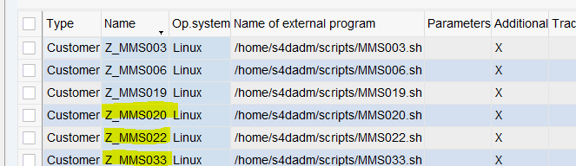

3.create a program to transfer the file

Sample Program made by gen  
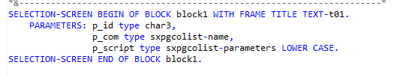

INCLUDE zmm_sftp_2_al11_top.

DATA : lv_dir TYPE eps2filnam,

lv_sftp TYPE eps2filnam,

lv_f_name TYPE string,

lv_dir_input TYPE sxpgcolist-parameters,

lt_files TYPE TABLE OF eps2fili,

lt_result TYPE STANDARD TABLE OF btcxpm,

ls_files TYPE eps2fili.

DATA: lv_os_script TYPE sxpgcolist-parameters.

REFRESH lt_result.

WAIT UP TO 4 SECONDS.

CALL FUNCTION 'SXPG_COMMAND_EXECUTE'

EXPORTING

commandname = p_com

additional_parameters = p_script

* OPERATINGSYSTEM = c_oper

* TARGETSYSTEM = SY-HOST

* DESTINATION =

* STDOUT = 'X'

* STDERR = 'X'

* TERMINATIONWAIT = 'X'

* TRACE =

* DIALOG =

* IMPORTING

* STATUS =

* EXITCODE =

TABLES

exec_protocol = lt_result

EXCEPTIONS

no_permission = 1

command_not_found = 2

parameters_too_long = 3

security_risk = 4

wrong_check_call_interface = 5

program_start_error = 6

program_termination_error = 7

x_error = 8

parameter_expected = 9

too_many_parameters = 10

illegal_command = 11

wrong_asynchronous_parameters = 12

cant_enq_tbtco_entry = 13

jobcount_generation_error = 14

OTHERS = 15.

IF lt_result IS NOT INITIAL .

WAIT UP TO 10 SECONDS.

ENDIF.

**SAP Client ID** and **OS Command** created by the BASIS team

I Don’t know what is the purpose of OS Script path and what to put in the parameters

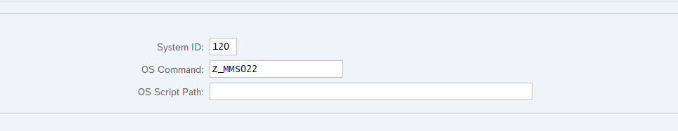

Successfully transfer file from SFTP folder into AL11 data/in folder

